Name: Mayurakshi Goel

E. No. 180078

**Objective:**

Write a program to implement Merge Sort

1. Using recursion
2. Without using recursion

**1. Using recursion**

**Code**

#include<stdio.h>

#include<conio.h>

void merge(int a[],int p,int q,int r){

int k,n,m,i,j;

n=q-p+1;

m=r-q;

int l[n+1],R[m+1];

l[n]=1000;

R[m]=2000;

for(i=0;i<n;i++){

l[i]=a[p+i];

}

for(j=0;j<m;j++){

R[j]=a[q+j+1];

}

i=0;

j=0;

for(k=p;k<=r;k++){

if(l[i]<=R[j]){

a[k]=l[i];

i++;

}

else{

a[k]=R[j];

j++;

}

}

while(i<n){

a[k]=l[i];

i++;

k++;

}

while(j<m){

a[k]=R[m];

m++;

k++;

}

}

void merge_sort(int a[],int p,int r){

int q;

if(p<r){

q=(p+r)/2;

merge_sort(a,p,q);

merge_sort(a,q+1,r);

merge(a,p,q,r);

}

}

void main(){

int n,i;

printf("Enter the number of elements: ");

scanf("%d",&n);

int a[n];

printf("Enter the elements of array:\n");

for(i=0;i<n;i++){

scanf("%d",&a[i]);

}

merge_sort(a,0,n-1);

printf("\nArray after sorting\n");

for(i=0;i<n;i++){

printf("%d\t",a[i]);

}

}

**Output:**

**Array is in sorted order**

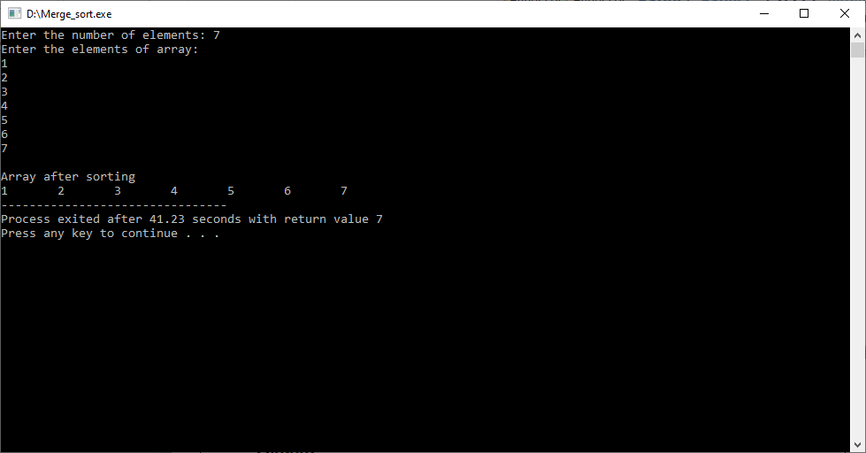

**Array is in reverse order**

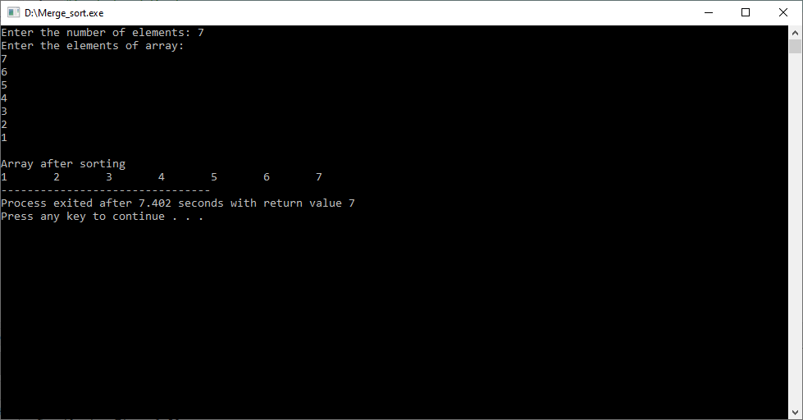

**Array is in random order**

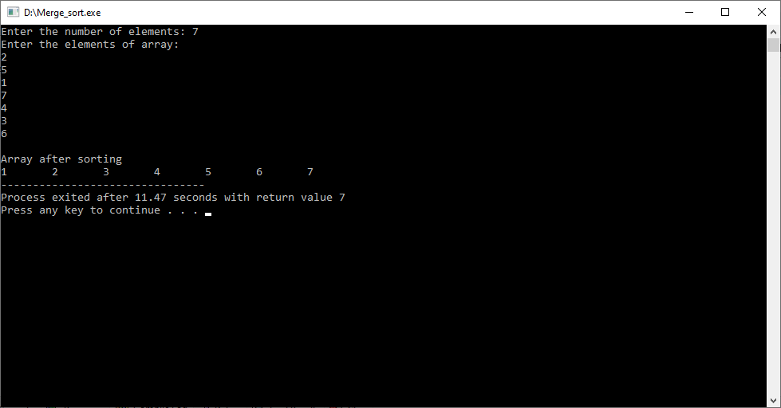

**2. Without using recursion**

**Code**

#include<stdio.h>

#include<conio.h>

void main(){

int i,j,k,n,size,l1,h1,l2,h2;

printf("Enter the number of elements: ");

scanf("%d",&n);

int a[15],temp[15];

printf("Enter the elements of the array:\n");

for(i=0;i<n;i++){

scanf("%d",&a[i]);

}

for(size=1;size<n;size=size*2){

l1=0;

k=0;

while(l1+size<n){

h1=l1+size-1;

l2=h1+1;

h2=l2+size-1;

if(h2>=n){

h2=n-1;

}

i=l1;

j=l2;

while(i<=h1&&j<=h2){

if(a[i]<=a[j] )

temp[k++]=a[i++];

else

temp[k++]=a[j++];

}

while(i<=h1)

temp[k++]=a[i++];

while(j<=h2)

temp[k++]=a[j++];

l1=h2+1;

}

for(i=l1;k<n;i++)

temp[k++]=a[i];

for(i=0;i<n;i++)

a[i]=temp[i];

}

printf("Array after sorting:\n");

for(i=0;i<n;i++)

printf("%d\t", a[i]);

}

**Output:**

**Array is in sorted order**

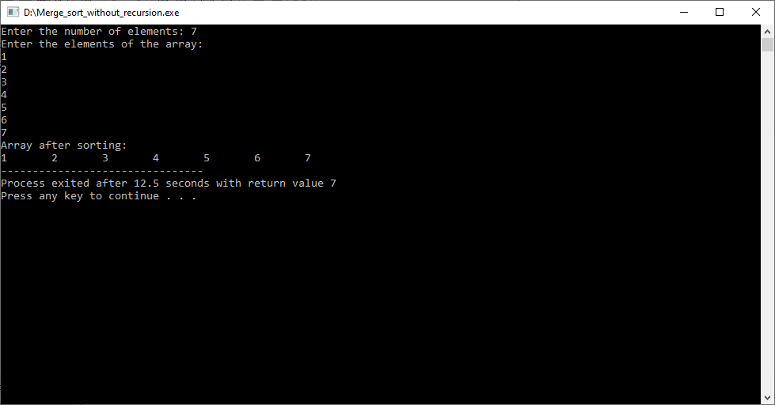

**Array is in reverse order**

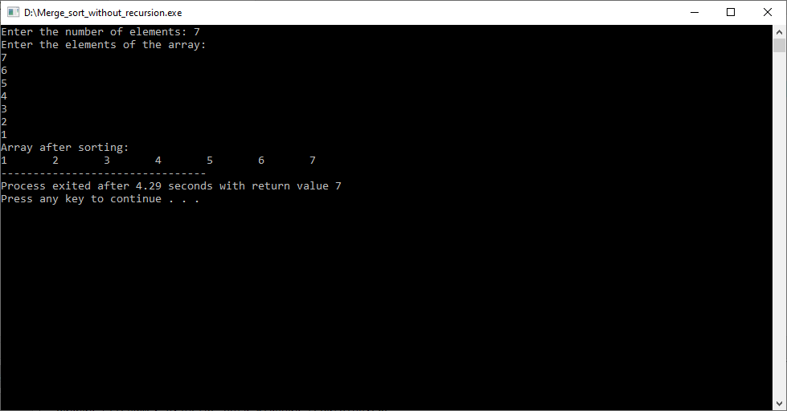

**Array is in random order**

